**Integrate Hbase with Hive and Load Data (Bulk Load) from Hive table to Hbase Table**

**For this I am having a table “employe” whose details I am going to load into Hbase by creating a external table ”employee” in hive with storage Handlers**

**Step1:We will create a table “Hive_employee” with column family “ employee_details” to which the data will be bulk loaded**

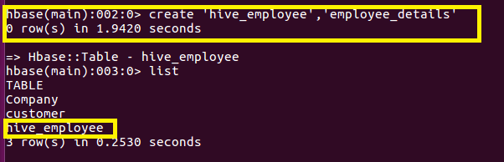

**Step2:We will create a external table which will be integrated with the above created Hbase Table using Storage Handlers**

**hbase.columns.mapping : It is used to map the Hive columns with the HBase columns. The first column must be the key column which would also be same as the HBase’s rowkey column.(In our case Emp_id )**

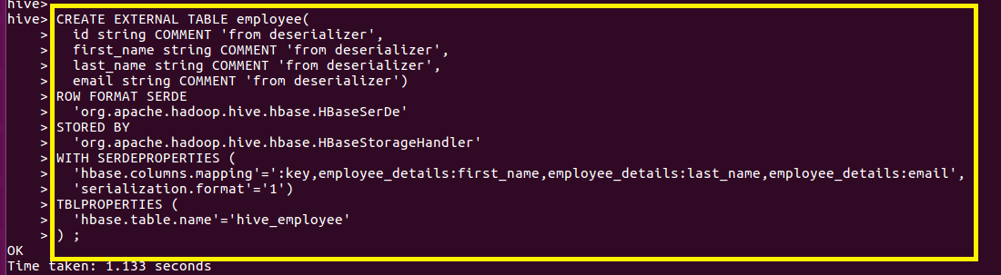

**Step3:Populating the data into the above created external hive table “employee”**

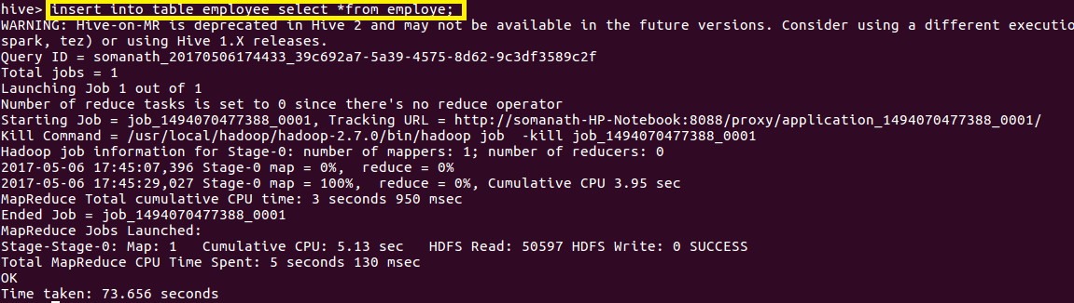

**Step4:output verification**

**Since we have Integrated the table with Hbase ,If we scan the Hbase ”hive_employee ”**

**table the data will be populated with Emp_id as rowkey and the remaining details as column qualifier**

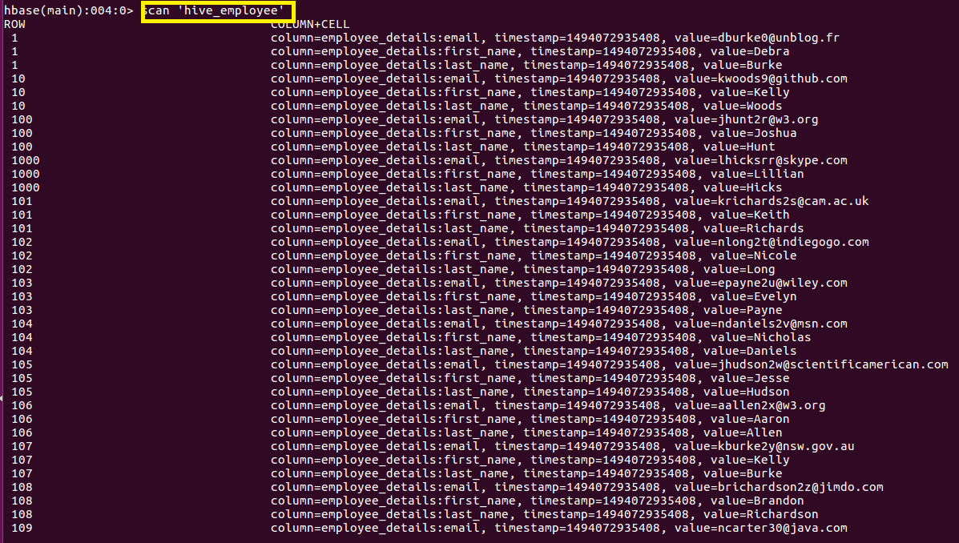

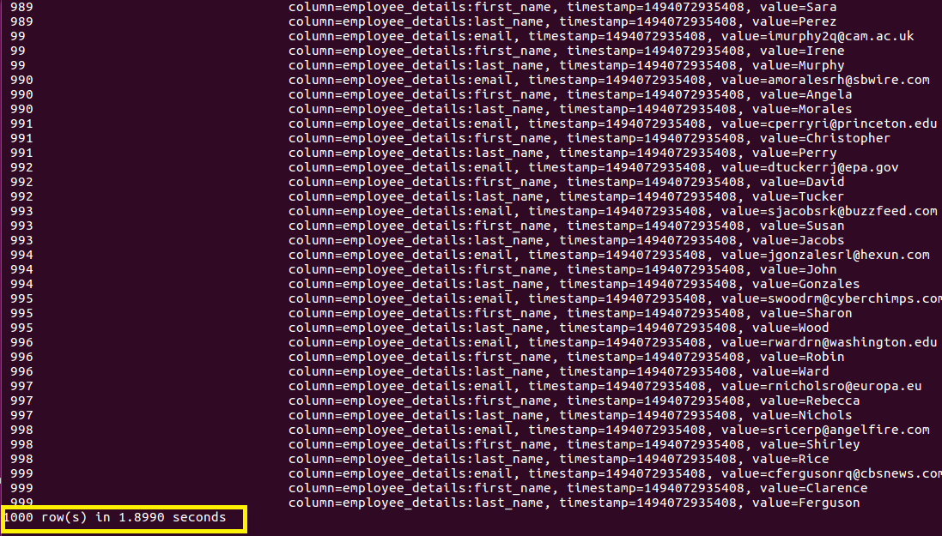

**Count is used to verify the 1000 rows inserted**

